

Bihi Towers 9th Floor, Room 5 Moi Avenue

P.O. Box 35351 – 00100, Nairobi, Kenya

TRIMLINE SYSTEMS & SOLUTIONS

Tel: 0710563359

Email: trimlinesys@gmail.com

# PRODUCT DESCRIPTION

# Mobile Banking and Bulk Sms

Contents

PRODUCT DESCRIPTION 1

AUTONOMOUS ATM BRIDGE 1

Process flow 1

Description 1

Features 2

Security 3

Pricing 3

Project Plan 3

## Process flow

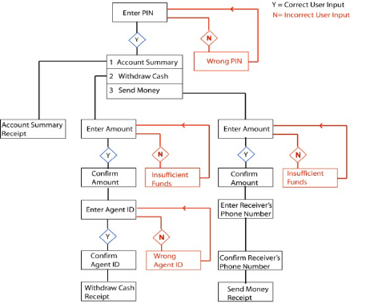

## Description

**Mobile banking** is a service provided by a [bank](https://en.wikipedia.org/wiki/Bank) or other [financial institution](https://en.wikipedia.org/wiki/Financial_institution) that allows its customers to conduct [financial transactions](https://en.wikipedia.org/wiki/Financial_transaction) remotely using a [mobile device](https://en.wikipedia.org/wiki/Mobile_device). Unlike the related [internet banking](https://en.wikipedia.org/wiki/Internet_banking) it uses software, usually called an [app](https://en.wikipedia.org/wiki/Mobile_app) or ussd, provided by the financial institution for the purpose. Mobile banking is usually available on a 24-hour basis. Some financial institutions have restrictions on which accounts may be accessed through mobile banking, as well as a limit on the amount that can be transacted. Mobile banking is dependent on the availability of an internet or network connection to the mobile device.

Transactions through mobile banking depend on the features of the mobile banking app provided and typically includes obtaining account balances and lists of latest transactions, [electronic bill payments](https://en.wikipedia.org/wiki/Electronic_bill_payment), remote check deposits, [P2P payments](https://en.wikipedia.org/wiki/Peer-to-peer_banking), and [funds transfers](https://en.wikipedia.org/wiki/Giro) to mobile money between a customer's or another's [accounts](https://en.wikipedia.org/wiki/Deposit_account). Some apps also enable copies of statements to be downloaded and sometimes printed at the customer's premises.

From the bank's point of view, mobile banking reduces the cost of handling transactions by reducing the need for customers to visit a bank for normal day to day transactions.

## Features

Below are some of the transaction types:

* Balance Enquiry
* Mini Statement
* All loans balances
* Apply for loans
* Loan Guarantor ship
* Cash withdrawal on different channels
* Cash deposit on different channels
* Withdrawal from agents
* Sms and email alerts
* Bill payments
* Self-registration
* Mobile Wallet
* Bulk/broadcast/Notification sms

## Security

**Web services** - Our mobile banking uses web services (APIs) to integrate to co-banking system NAV. This makes it easy to control the mobile banking from Navision. This eliminates the need for special database rights as the mobile banking account is set within the co-banking system.

**Encryption** – All phone numbers are encrypted and unreadable to human eyes. This means that no phone number can be changed in the backend. The encryption is done at the point the customers number is registered to the system. The process of linking the phone numbers to account must have a make and a checker.

**No Passwords** –Our Navision web services have been configured to use access keys to login to Navision. These access keys are only used as by the APIs and no user can login to Dynamics Navision using the access key.

**Auto posting** – Dynamics Navision has a job scheduler which is used to process set tasks at desired time. If not configured nicely the Job scheduler can be a challenge to use. We have incorporated the process of updating the customers’ accounts(posting) into our mobile banking application, with this the task of setting up the job scheduler becomes obsolete.

## Pricing

|  |  |  |  |  |
| --- | --- | --- | --- | --- |
| **Application**  **Area** | **Functional Components** | **Quantity** | **Unit Price** | **Total (Kshs)** |
| **Mobile Banking** | Initial Software Development Costs | 1 | 500,000.00 | 500,000.00 |
| Setup and integrations | 1 | 200,000.00 | 200,000.00 |
| Customizations | 1 | 450,000.00 | 450,000.00 |
| Integrations to Mobile money | 1 | 250,000.00 | 250,000.00 |
| Transactional fee % of sacco income | 35% |  |  |
| **TOTAL** |  |  | **1,400,000.00** |

## Project Plan

|  |  |
| --- | --- |
| **Item** | **Duration( days)** |
| Setup | 2 |
| Customization | 3 |
| Integration to mobile money | 5 |
| **Total** | **10** |